

Medical Costs Finder   
Specialist Portal User Guide

Version 2.0

October 2024

**Terms and definitions**

| Term | Definition |
| --- | --- |
| Authorised person | A person authorised by a specialist to access their Medical Costs Finder Portal account. There are two types of authorised persons:   * Authorised representative: Can add and edit profile information and publish it to the website. * Support staff: Can add information but cannot publish it to the website. Any information entered will need to be submitted the specialist or authorised representative for approval prior to publishing on the website. |
| Dashboard | Allows changes to a specialist’s locations, services, indicative fees and arrangements with insurers. |
| Gap arrangement | A specialist’s agreement with an insurer about the out-of-pocket cost to a patient for the service provided in hospital. It is the difference between a specialist’s fee, what Medicare pays, and what the insurer pays. There are three types of gap arrangements: no gap, known gap and no arrangement. |
| Indicative fees | A general fee charged by a specialist for a medical service. It is not a quote (as patients should have a conversation with specialist about their specific needs). The Medical Costs Finder will automatically calculate the patient’s out-of-pocket cost, and Medicare and insurer contributions. |
| Location | This refers to **practice locations** where services are provided to patients.  A ***primary*** **practice location** must be added as part of onboarding to the Portal. |
| Onboarding | Onboarding in the Medical Costs Finder Portal comprises of three steps: register an account, create a profile, publish a profile. |
| Preview | A feature allowing a specialist’s information to be viewed as it would be displayed on the MCF website, prior to publishing. |
| Service | The common medical services for which specialists can provide indicative fees and gap arrangements on the Medical Costs Finder. These services were identified and agreed by nominees of specialist colleges/craft groups, and are considered highly common and beneficial to patients to be on the Medical Costs Finder. |

**Table of Contents**

1. Introduction 1

1.1 The Medical Costs Finder 1

1.2 Technical support 2

2. Onboarding in the MCF Portal 3

2.1 Overview 3

2.2 Register an account 3

2.3 Create a specialist’s profile 7

2.4 Publish a specialist’s profile 10

3. Manage a Specialist Profile 13

3.1 Dashboard 13

3.2 Add locations 14

3.3 Add, edit, or remove a service and indicative fee 16

3.4 Add, edit, or remove an insurance provider 18

3.5 Public profile 20

3.6 Authorised persons 21

3.7 Accounts and settings 22

3.8 Edit contact details 23

3.9 Log out 24

3.10 Go to the MCF website 24

Appendix – How indicative fees are calculated and displayed 25

## Introduction

This user guide has been developed by the Department of Health and Aged Care (the department) to help medical specialists and their staff use the Medical Costs Finder Specialist Portal (the Portal).

The user guide is available for download on the [Portal resources page](https://medicalcostsfinderportal.health.gov.au/Signin?HelpGuide=1) and will be updated from time to time as required.

### The Medical Costs Finder

#### About the Medical Costs Finder

The Medical Costs Finder (MCF) is a public-facing website that helps consumers:

* learn about what contributes to out-of-pocket costs for private health treatment, with educational material to guide them through their healthcare journey
* find typical out-of-pocket costs for ~1,300 common GP and specialist services for the last financial year of data held by the department
* for a subset of these services, view indicative fees charged by specialists under gap arrangements with insurers (no gap, known gap and no arrangement).

Specialists choose to share their indicative fees and gap arrangements on the website by registering in the Portal. By participating, medical specialists would be:

* helping patients understand different factors that affect their private health treatment costs
* preparing patients to have an informed discussion about fees
* contributing to greater out-of-pocket costs transparency for patients across Australia
* following the AMA’s position on [Setting medical fees and billing practices 2024](https://www.ama.com.au/articles/setting-medical-fees-and-billing-practices-2024) and [Informed financial consent 2024](https://www.ama.com.au/articles/informed-financial-consent-2024) and [Informed financial consent guide](https://www.ama.com.au/sites/default/files/2024-10/AMA-Informed-Financial-Consent-Guide-October-2024.pdf) 2024.

#### Available specialties and services

The services for which specialists can provide indicative fees and gap arrangements were identified and agreed by nominees of specialist colleges/craft groups. These services were considered highly common and beneficial to patients.

Table 1 – Available specialties

| Specialties currently listed on the MCF | | |
| --- | --- | --- |
| Cardiology  Cardiothoracic surgery  Gastroenterology and hepatology  General surgery (abdominal and gastrointestinal) | General surgery (breast)  Obstetrics and gynaecology  Ophthalmology  Orthopaedic surgery | Otolaryngology – ENT  Plastic and reconstructive surgery  Urology |

Additional specialties will be added to the MCF over time. To have a specialty added, please register interest by emailing the project team at [OOPTransparency@health.gov.au](mailto:OOPTransparency@health.gov.au).

#### The MCF Portal

The MCF Specialist Portal (the Portal) is a private, secure platform for medical specialists and their staff to provide information that becomes published on the website.

Specialists who register an account in the Portal can create a profile that includes their:

* professional details – qualifications, experience, credentials, languages spoken etc
* practice locations
* indicative fees and any gap arrangements for common services.

All information in the specialist profile is controlled by the specialist and their authorised representatives, who can edit, publish, unpublish, or delete content at any time.

### Technical support

The **MCF Contact Centre** is available during business hours (Australian Eastern Standard/Daylight Time) to assist with registration and technical troubleshooting.

**Phone:** 1800 318 210

**Email:** [mcfportalsupport@health.gov.au](mailto:mcfportalsupport@health.gov.au)

## Onboarding in the MCF Portal

### Overview

Onboarding in the Portal is a three-step process:

1. Register an account
2. Create a specialist’s profile
3. Publish a specialist’s profile to the website.

Once a specialist starts the registration process, it must be completed (progress cannot be paused and saved). It takes 5 minutes to register.

Once a specialist’s account is registered, they can log in any time to create a profile. They can also add, edit, and remove information from their profile at any time.

To publish a specialist’s profile to the MCF website, their profile must include indicative fee information for at least one service. This can include MBS item number 104 - Initial specialist appointment, or MBS item number 110 - Initial consultant physician appointment.

### Register an account

Table 3 – Register

|  |  |
| --- | --- |
| **Time it takes** | 5 minutes |
| **Who can do it** | Specialist |
| **Minimum information required** | PRODA **or** myGovID  **and**  AHPRA registration number **or** Medicare provider number.  **Optional**: the name and PRODA **or** myGovID email address for a person (usually a practice manager) to nominate as an authorised representative. |
| **Important to know** | ***Important:*** The specialist’s name for digital identity and MCF Portal registration must match the specialist’s name on the AHPRA registration.  If they don’t match, contact the team at [OOPTransparency@health.gov.au](mailto:OOPTransparency@health.gov.au) for assistance. |

#### How to register

* Go to the [MCF Portal sign-in page](https://medicalcostsfinderportal.health.gov.au/Signin?ReturnUrl=%2F)
* Choose either **Login with PRODA** or **Login with Digital Identity** and follow the steps.

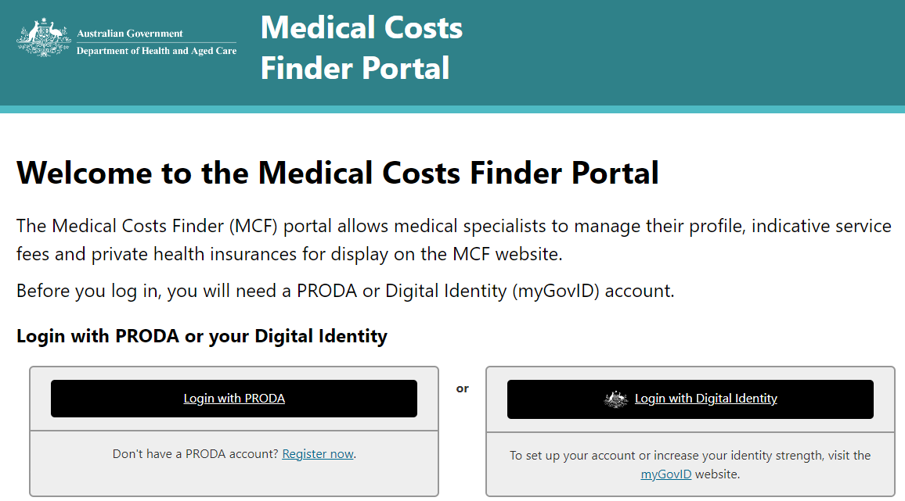

*Figure 1 – MCF Portal landing page*

On the MCF Portal registration page:

* Provide either a AHPRA registration number or Medicare provider number
* Select a specialty
* Consent to the Terms of Use and Privacy Notice
* Click on the Register button.

*Figure 2 –registration page*

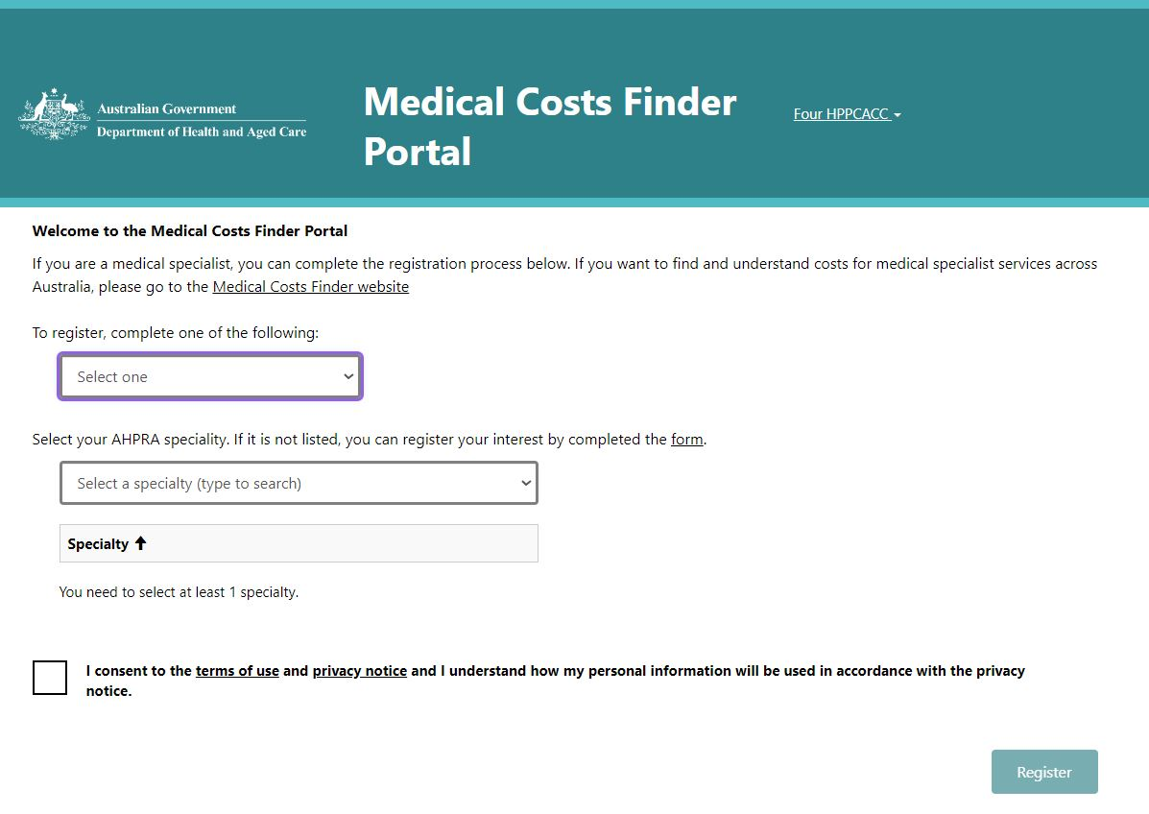

***Note:*** *There is a total of three attempts allowed for a specialist to register before they get locked out. If a specialist gets locked out, please contact the* [*MCF Contact Centre*](mailto:mcfportal.support@health.gov.au)*.*

#### Invite an authorised representative (optional)

Once a specialist has registered, they can invite an authorised representative to assist in completing and managing their profile. This person will also be able to publish profile information to the MCF website.

***Note:*** *If a specialist skips this step, they will need to complete their profile before getting another opportunity to invite an authorised representative.*

A specialist will need the following from the authorised representative to invite them:

* their consent to be invited and for their name and email address to be disclosed to the department (in order to comply with privacy legislation)
* their first and last name
* their PRODA or myGovID email address.

*Figure 3 – invite an authorised representative*

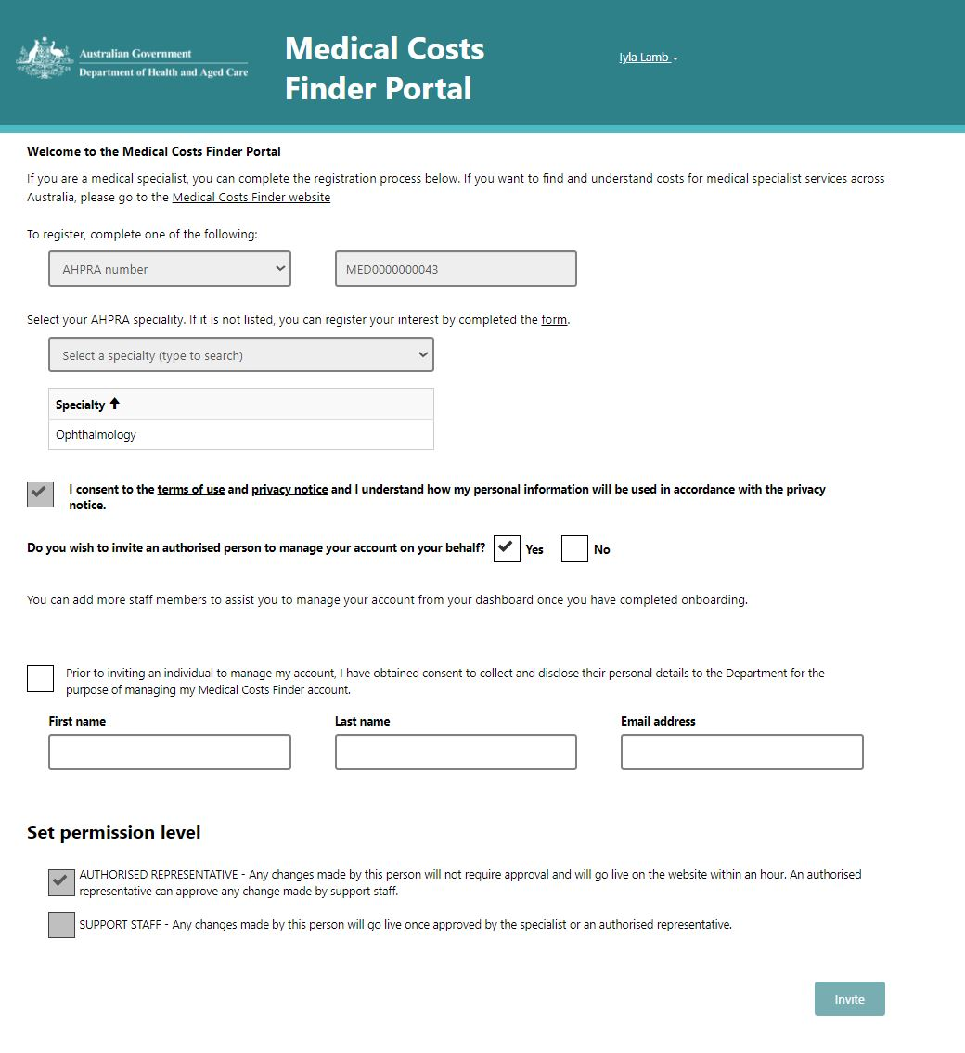

Add the above information in the relevant fields and click the **Invite** button.

The invitee will receive an email with a unique code to allow them to register as an authorised representative. The code is valid for 30 days. If the authorised representative does not register in that time, the specialist will need to send a new invitation.

***Note:*** *When a specialist’s profile is complete (after following sections* *2.3* *and* *2.4**),* *they or their authorised representative will also be able to invite support staff to provide extra assistance with managing the specialist’s profile***.** *Support staff can make changes to a profile but cannot publish information without approval from a specialist or an authorised representative.*

#### For authorised representatives – accept an invitation

To gain access to the Medical Costs Finder Portal as an authorised representative, a person will need an invitation from their specialist, and a PRODA account or a myGovID with a basic identity strength (visit [how to set up myGovID](https://www.mygovid.gov.au/set-up)).

When a specialist sends an invitation to an authorised representative, the person will receive a system-generated email with a link and a code. Using this link, the person will be taken to the Portal landing page, where they will login either with a PRODA account or myGovID. (Refer to section 2.2.1.)

***Note:*** *Check the spam and junk folders if a person is expecting an email invitation and it doesn’t appear in the email inbox.*

#### What next?

After a specialist has invited an authorised representative, they can log out and ask that person to build their profile and complete the onboarding process.

If a specialist does not invite an authorised representative, or wishes to build their profile themselves, continue to section 2.3 below.

### Create a specialist’s profile

Table 4 – Create specialist profile

|  |  |
| --- | --- |
| **Time required** | 5 minutes |
| **Who can do it** | Specialist  Authorised representative |
| **Information required** | Details of:   * Specialist qualifications, credentials, etc. * Primary practice location * One out-of-hospital service (eg. initial specialist or consultant physician appointment) * Indicative fee for that service   Note that additional services, including in-hospital services, can be entered as well. |
| **Important to know** | **Qualifications** must be:   * related to a specialist’s registration with the relevant medical college * recognised by the relevant Australian medical college. |

***Contact information****: A specialist’s phone number and email address will* ***NOT*** *be published on the website. They are required by the department in the event it is necessary to contact a specialist about their account.*

#### Enter a specialist’s details

The following information can be entered for a specialist:

* Display name: the name that will be shown on the public website. It does not have to be the same as the specialist’s registration name or Digital Identity name
* Years of experience
* Fellowships e.g. FRACS
* Qualification including institute and qualification year.

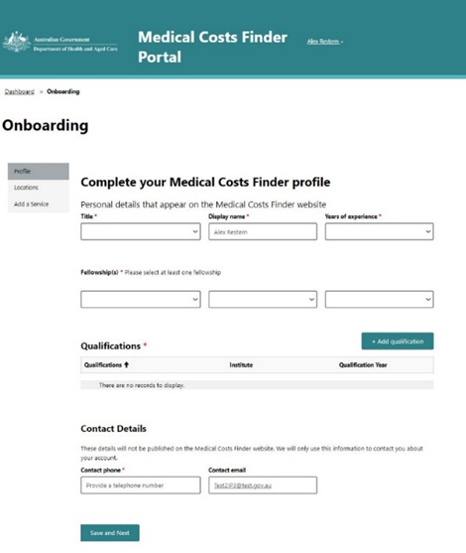

*Figure 4 – add specialist’s details*

***Note:*** *Contact* [*MCF Contact Centre*](mailto:mcfportal.support@health.gov.au) *if the specialist’s credential, qualification, or institute is missing from the dropdown list.*

*Figure 5 – add specialist qualifications*

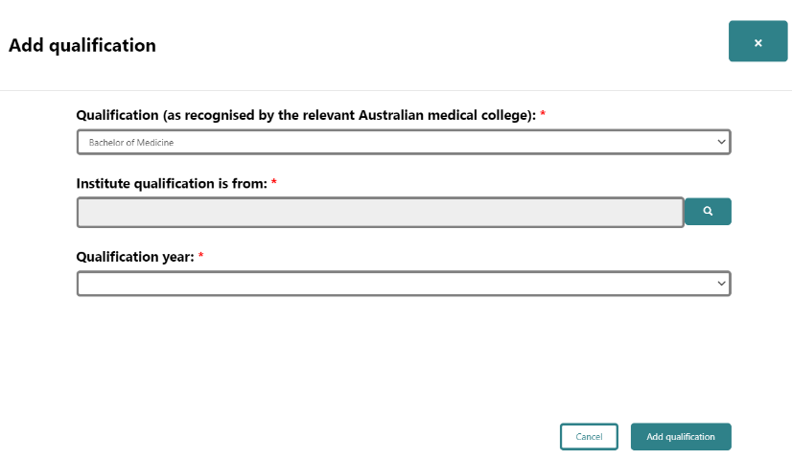

#### Enter primary practice location

During onboarding, only one practice location can be added. Once onboarding is complete, other practice locations can be added from the Dashboard.

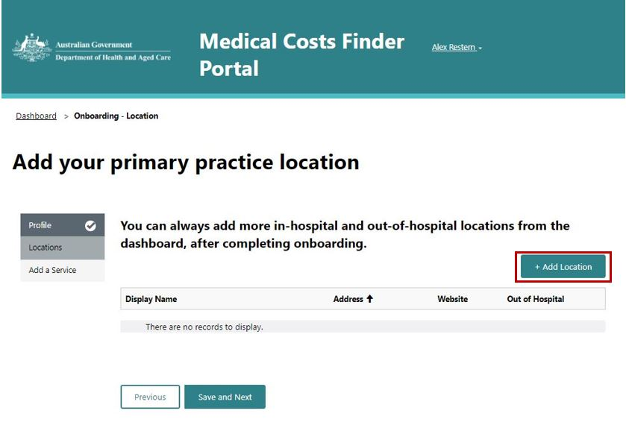

*Figure 6 – add primary practice location*

Add the details of the primary practice location and click the **Publish** button.

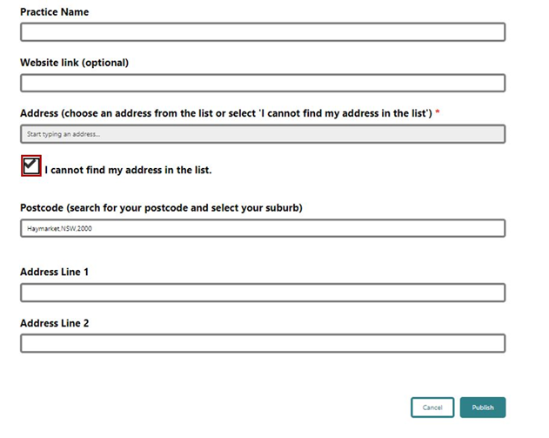

*Figure 7 – add primary practice details*

***Tip:*** *Select the checkbox to add an address manually if it doesn’t appear in the search/dropdown menu.*

#### Add a service with indicative fee information

To complete a specialist’s profile, add one out-of-hospital service from the dropdown list on the ‘Add your first service’ screen. Depending on the specialisation, this can include MBS item number 104 - Initial specialist appointment, or MBS item number 110 - Initial consultant physician appointment.

The following window will appear. An indicative fee can be entered here.

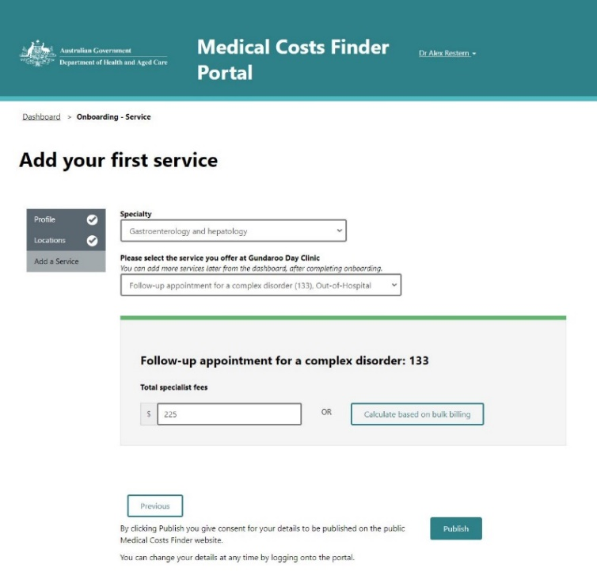

*Figure 8 – add the first service*

***Note:*** The ‘Calculate based on bulk billing’ button will automatically calculate an indicative fee that results in a patient being bulk billed.

The final step is to preview and publish the profile to the website.

### Publish a specialist’s profile

Table 5 – Publish specialist profile

|  |  |
| --- | --- |
| **Time it takes** | Less than 1 minute |
| **Who can do it** | Specialist  Authorised representative |
| **What’s required** | Completion of steps one and two above. |

After clicking **Publish** on the service page, a summary of the location, service and the indicative fee added will appear.

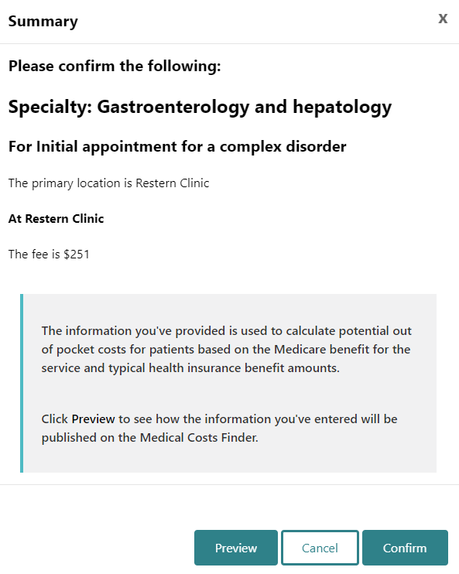

*Figure 9 – summary of details*

*Figure 10 – preview of profile*

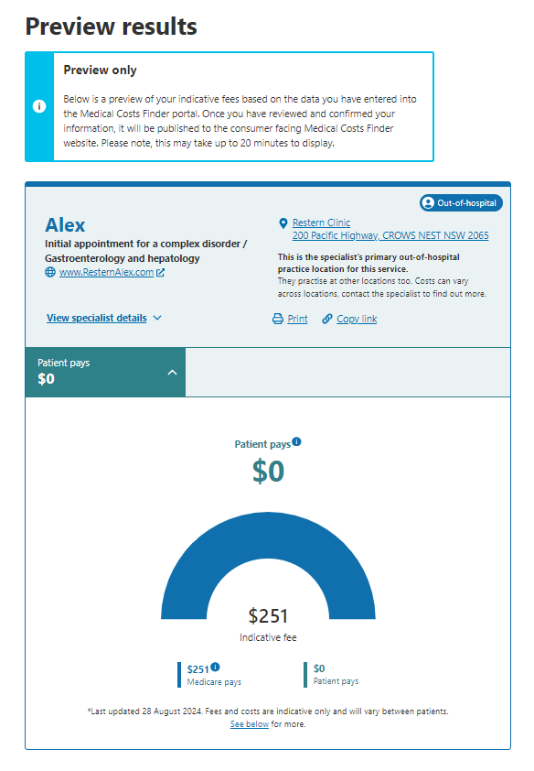

To preview the information which will be displayed on the website, click on the **Preview** button.

The preview will open in a new tab. If the changes are correct, close the preview tab and click on the **Confirm** button to publish the information to the website.

To make any changes to the information, click **Cancel.**

***Note:*** *The ‘Medicare pays’ amount might change after a specialist’s information is published, due to real-time MBS fee updates.* [*MBS Online - Latest News*](https://www.mbsonline.gov.au/internet/mbsonline/publishing.nsf/Content/news) *provides monthly updates on MBS items.*

**Onboarding is complete**

A dialog box will appear to confirm a specialist’s profile has been published.

After clicking OK in the dialog box, the Dashboard will appear where a specialist and staff can manage the account and add other locations, services and indicative fees.

## Manage a Specialist Profile

Everything relating to a specialist’s locations, services, indicative fees and arrangements with insurers can be managed on the Dashboard.

### Dashboard

*Figure 11 – dashboard*

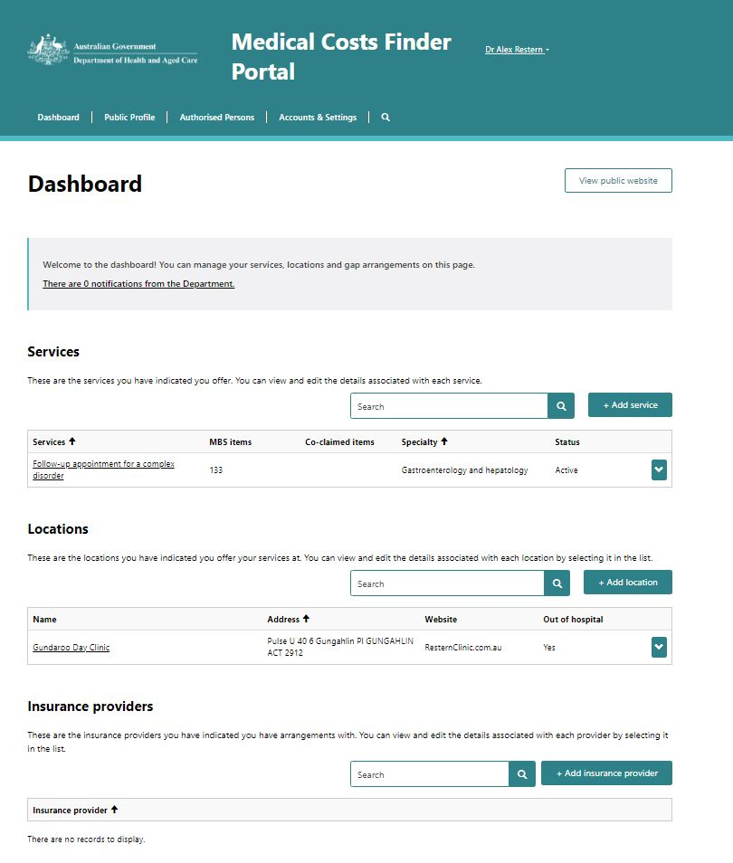

### Add locations

Locations can be added, edited and removed from the Dashboard.

***What to know before starting:*** *Practice locations must be added, before services can be added. It means specialists can have different services and indicative prices at each location.*

#### Add a location

* Select ‘Add location’ from the ‘Locations’ section of the Dashboard.

*Figure 12 – add location from Dashboard*



*Figure 13 – add practice location*

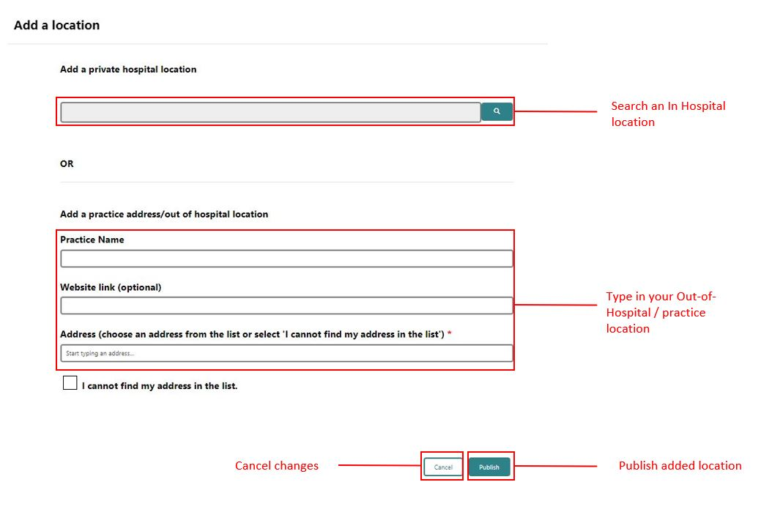

To add a private hospital location:

* select the magnifying glass icon and search by location name, or filter the drop-down list by state
* select the location and click ‘Publish’.

To add a private practice or out of hospital location’:

* choose and address from the list, or
* select the checkbox to add a practice address manually if it is not available in the list.

Click ‘Publish’.

OR

When a location is added, a dialog box will appear to add a service. A service can then be added (or it can be added later from the Dashboard).

***Note:*** *The list of private hospitals only includes those that have been declared to the department. If a hospital should be on the list, contact* [*OOPTransparency@health.gov.au*](mailto:OOPTransparency@health.gov.au)*.*

#### Edit a location

* Use this to edit a location’s indicative fees and gap arrangements
* On the Dashboard, find the location to edit and click on the down arrow
* Click ‘Edit’ in the dropdown menu to be taken to the ‘edit location’ page
* Make the desired changes.

*Figure 14 – edit a location*

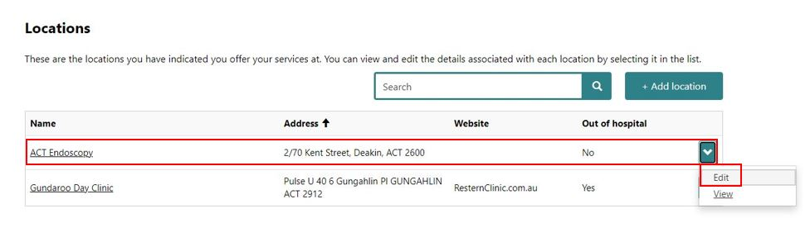

#### Update location address

* Use this to update a location address, website and practice name
* On the Dashboard, find the location to edit and click on the down arrow
* Click ‘Update Address’ in the dropdown menu to be taken to the ‘edit location’ page
* Update the address.

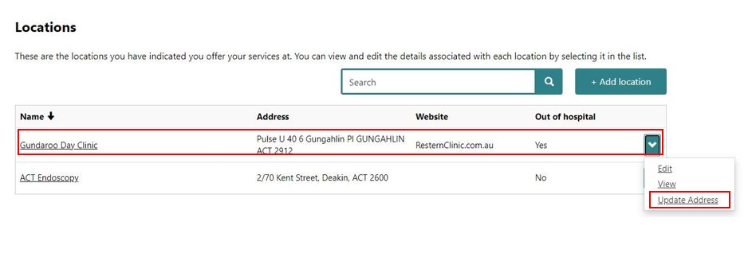

*Figure 15 – update location address*

#### Remove a location

* On the Dashboard, find the location to remove and click on the down arrow
* Select ‘View’ in the dropdown menu to go the View screen and choose the option to remove the location (see figure 16).

*Figure 16 – Remove a location*

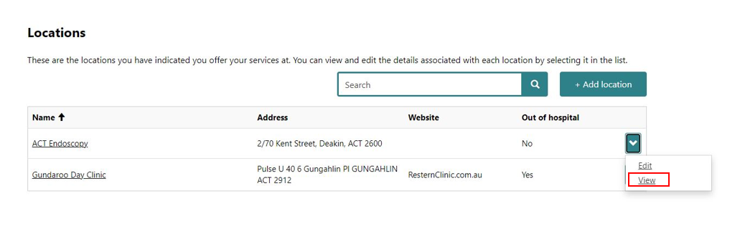

### Add, edit, or remove a service and indicative fee

***What to know before starting:***

*Services are linked to locations, and a specialist must publish one indicative fee for a service in a primary location as part of their onboarding to the Portal.*

*Publishing indicative fees for other services and locations is optional.*

*For each service, the MCF shows:*

* *the primary MBS item number any co-claimed numbers that make up a service*
* *whether the service is provided in- or out-of-hospital.*

***Note:*** *Some services have other MBS items that could be used to describe the service.   
The MBS item numbers on the MCF represent the most typical definition of a medical service so specialists can provide their indicative fees.*

#### Add a service and indicative fee

* From the Dashboard, select ‘Add service from the ‘Services’ section.

*Figure 17 – add a service*

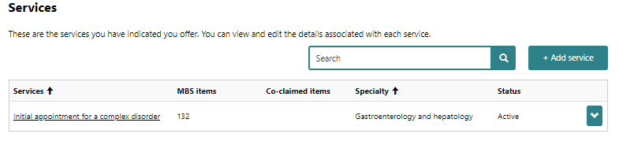

***Can’t find a service?***

* *Only services related to a specialist’s selected specialty will be displayed.*
* *If a service is not listed, check whether another specialty needs to be added (under Public Profile on the Dashboard).*

*Contact* [*OOPTransparency@health.gov.au*](mailto:OOPTransparency@health.gov.au) *to nominate additional services to the MCF Portal.*

#### Edit a service and indicative fee

* On the Dashboard, find the service to edit and click on the down arrow
* Click ‘Edit’ in the dropdown menu to be taken to the ‘edit service’ page
* Make the changes.

*Figure 18 – edit a service*

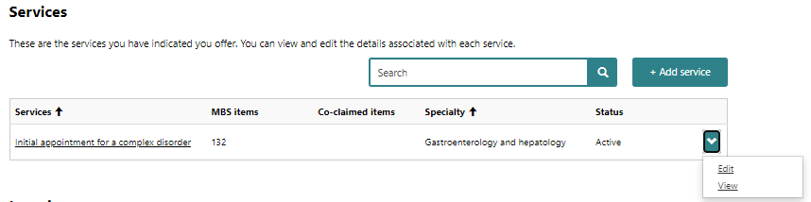

*Figure 19 – edit a service: detail*

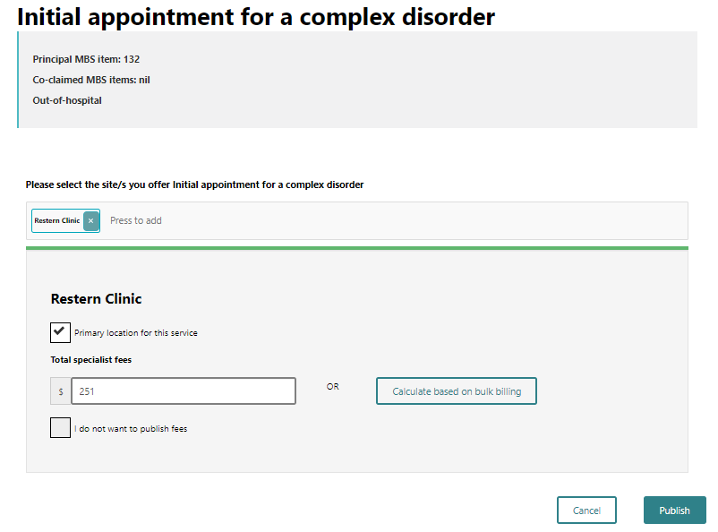

#### Remove a service and indicative fee

* On the Dashboard, find the service to edit and click on the down arrow
* Click ‘View’ in the dropdown menu to be taken to the ‘view service’ page
* Click ‘Stop displaying this service’ to remove the service. The service will no longer be displayed on a specialist’s profile.

*Figure 20 – remove/stop displaying a service on a specialist’s profile*

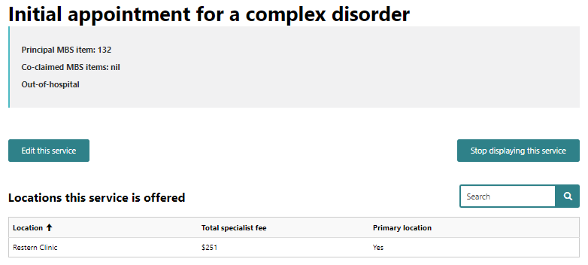

### Add, edit, or remove an insurance provider

Gap arrangements with insurers can be managed via the Dashboard.

#### Add an insurance provider and gap arrangement

* From the Dashboard, select ‘Add insurance provider’
* Select the insurance provider from the dropdown menu (figure 21) or copy details from an existing insurance provider (if the provider has already been added) (figure 22).

*Figure 21 – add an insurance provider*

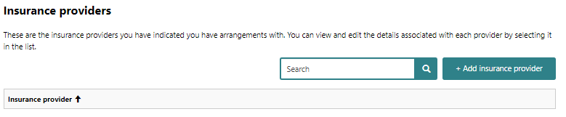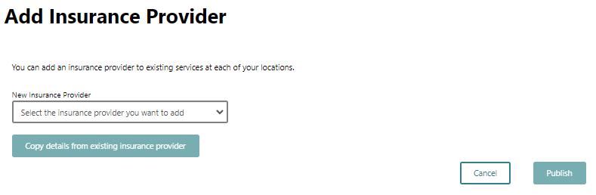

*Figure 22 – Add an insurance provider: dropdown*

#### Edit insurance providers and gap arrangements

To edit an insurance provider arrangement, select the insurer from the Dashboard. On the edit page, the following options are available:

* edit the gap arrangement for the service by location
* select a ‘no gap’ arrangement at the location
* remove an arrangement with a provider.

**TIP:** Enter a whole number of dollars for gap arrangements.

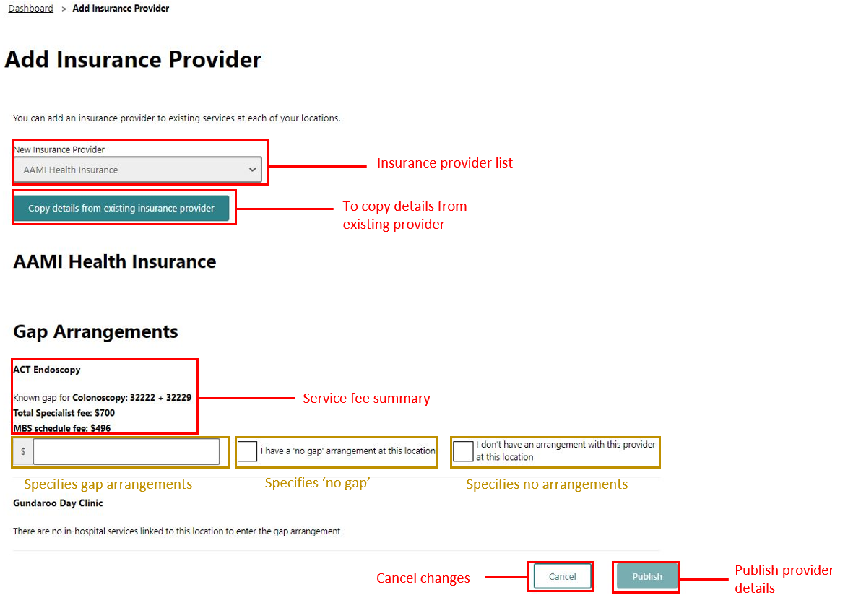

*Figure 23 – edit insurance providers and gap arrangements*

### Public profile

Qualitative details about a specialist can be managed on the Public Profile page.

Click the ‘Edit’ button to add or update any of these details.

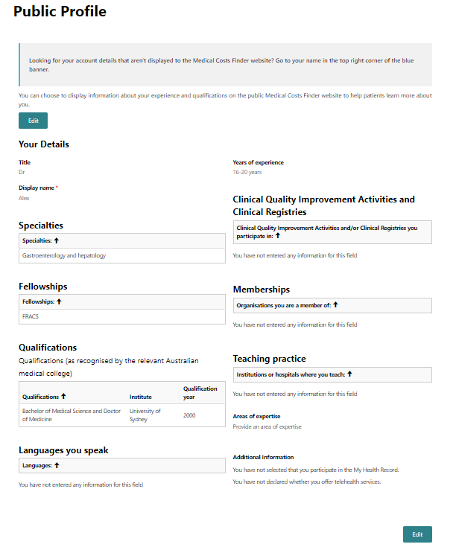

*Figure 24 – public profile information*

### Authorised persons

Staff who can access and manage a specialist’s profile can be invited and edited from the Authorised Persons page (see section 2.2.2):

* click the ‘Add authorised person’ button, complete the form and choose the permission level
* click ‘Invite’ to send that person an email with a unique code that will allow them to register as an authorised person. The code will remain valid for 30 days. If it is not used in that time, a new invitation must be sent.

***Note:*** *Remember to use the PRODA* ***or*** *myGovID email address for a person who is nominated as an authorised representative.*

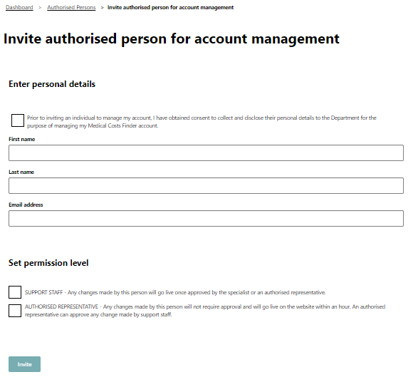

*Figure 25 – authorised persons*

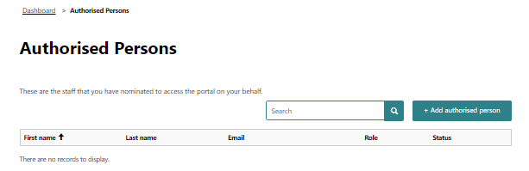

### Accounts and settings

The following actions can be performed at Accounts and Settings:

* pause publishing a specialist’s profile
* cancel an account
* see the history of changes in the account.

*Figure 26 – accounts and settings*

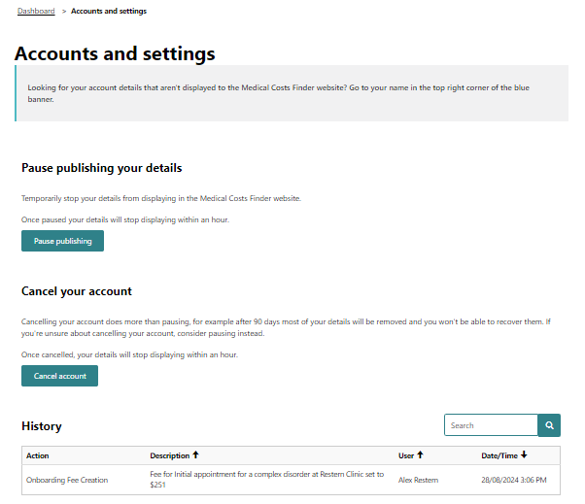

### Edit contact details

The department may use the contact details provided to contact a specialist about their account.

Only a specialist can see these contact details (i.e. the details are not published on the MCF website). An authorised representative or support staff can see their own details, but not their specialist’s contact details.

Users can edit their own contact details by selecting their name in the top right-hand corner of the screen, then clicking edit.

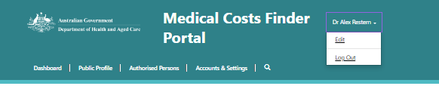

*Figure 27 – edit contact details*

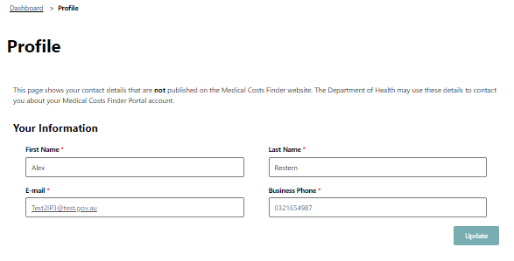

Click **Update** to save the changes (the changes will not be saved otherwise).

***Note:*** *These contact details are* ***not*** *published on the MCF website.*

### Log out

Log out by going to the name in the top right-hand corner.

*Figure 28 – log out*



### Go to the MCF website

To visit the MCF, navigate to the Dashboard and select ‘View public website’ in the top right-hand corner.

*Figure 29 – go to the website*

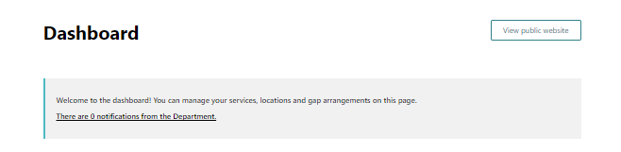

## Appendix – How indicative fees are calculated and displayed

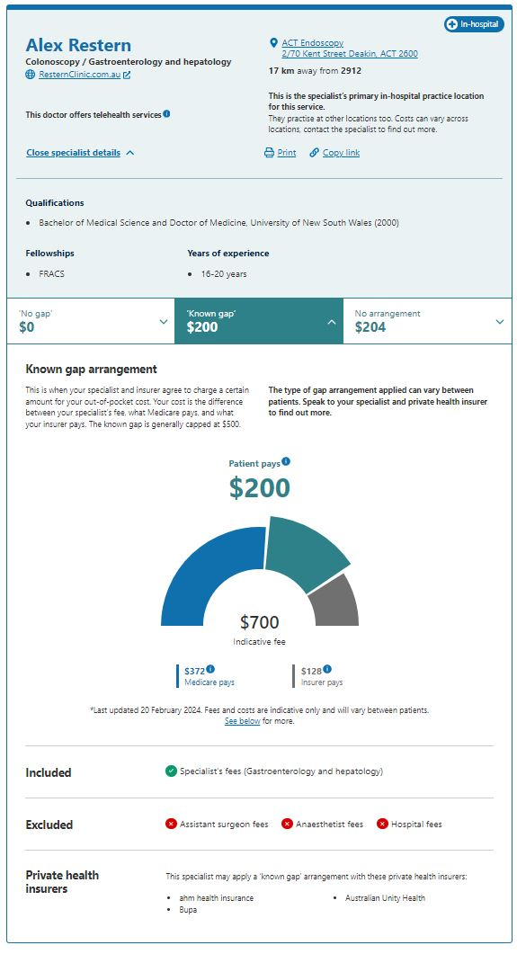

This example uses mock information and data to demonstrate how indicative fees are displayed on the MCF.

The Medicare contributions are automatically calculated using the MBS item numbers.

The insurer contributions are automatically calculated using the MBS item numbers and the gap arrangements between a specialist and their insurance provider.

**Note:** The MCF does not provide quotes for medical services. Specialists are only asked to provide *indicative* fees.



© 2024 Commonwealth of Australia as represented by the Department of Health and Aged Care.

This work is copyright. You may copy, print, download, display and reproduce the whole or part of this work in unaltered form for your own personal use or, if you are part of an organisation, for internal use within your organisation, but only if you or your organisation:

(a) do not use the copy or reproduction for any commercial purpose; and

(b) retain this copyright notice and all disclaimer notices as part of that copy or reproduction.

Apart from rights as permitted by the *Copyright Act 1968* (Cth) or allowed by this copyright notice, all other rights are reserved, including (but not limited to) all commercial rights.

Requests and inquiries concerning reproduction and other rights to use are to be sent to the Communication Branch, Department of Health and Aged Care, GPO Box 9848, Canberra ACT 2601, or via email to [copyright@health.gov.au](mailto:copyright@health.gov.au)