A guide for GPs – referrals to medical specialists
  - A guide for GPs to help their patients make better informed decisions
Good medical practice involves providing patients with the knowledge and understanding to make informed choices regarding their medical care. The Australian Medical Association (AMA) also has a guide on informed financial consent for doctors and patients.¹
Patients who actively engage with their GP in the decision to seek medical specialist services may:
- be more likely to see a specialist and receive appropriate health care²
- have less financial stress¹
- be more likely and confident to engage in shared decision-making.³

Does your patient want to be involved in choosing their specialist?
- Encourage your patients to be involved.4,5

Let your patient know they can be involved in making the decision about which specialist they are referred to by you.4 Discuss and clarify patient needs and preferences
- Ensure your practice keeps a current list of specialists for your patients.4,⁶
- Consider the factors below when compiling and updating the list of specialists.4,⁶

Field of practice
Your knowledge of specialists’ fields of practice and subspecialties are critical in ensuring appropriate referrals. You should be able to explain to patients why you have made a certain referral when there are multiple specialists in the same field.

Out-of-pocket costs
You can help your patients find out more about out-of-pocket costs.⁶
Ensure your patients understand they can receive a high standard of care across both the public and private health systems.⁶ As an Australian, there is no cost associated with the public health system.
Remind those with private health insurance to contact their insurer as early as possible to discuss what their policy covers and potential out-of-pocket costs.
Encourage awareness of informed financial consent for patients who may choose to access private specialist services, emphasising the importance of a patient having full knowledge of potential costs prior to receiving any services.⁶

Accessibility
Let patients know that seeing a specialist privately could mean less wait time than the public system, but that wait times vary between private specialists.4

Location
Consider convenience, particularly travel time and specialist hours, for your patient and for their family and friends, if a hospital stay is expected. If the most appropriate specialist is far from your patient’s home, some private health insurers will cover travel and accommodation costs – patients will need to check this with their insurer.

Compatibility
The compatibility of communication styles between your patient and their specialist can influence your patient’s overall satisfaction and confidence.⁷

Recommend one or more specialists
Recommend one or more specialists and explain why each might be a good fit. Weigh up the pros and cons of factors important to your patient.4
If there is a single predominant factor, such as your patient cannot pay privately, the recommendation can be simple. However, when there are competing factors, your patient’s preferences may have a more significant role in driving the recommendation.
Let your patients know about the Medical Costs Finder when talking about treatment options. Educational resources are available for patients at medicalcostsfinder.health.gov.au/resources.

Does your patient need to decide now (is this urgent)?
If an immediate decision is not required, ask your patient if they want more time to consider their options.
- Use a shared decision-making approach when considering specialist options.
- Give your patient more time if they need to weigh up the pros and cons of different factors, or do research of their own about recommended specialists.

Schedule a follow-up appointment
It may be helpful for you to have a discussion with your patient at a follow-up appointment. This option may also apply if you need more time to consult with colleagues about which specialist to recommend.

Referral requirements and options
At the time of consultation, ensure minimum requirements for a referral are met and that your patient understands the period their referral is valid for. Minimum requirements for a referral include:⁸
- must be in writing (i.e. it cannot be made verbally), and include the signature of the referring practitioner (or a digital signature in the case of an e-referral)
- must include relevant clinical information about the patient’s condition for investigation, opinion, treatment and/or management
- must include the date of the referral
- the patient’s GP is to be named for specialist-to-specialist referrals, or a statement is to be included that the patient is unable or not willing to nominate their GP.
In most settings, referrals do not need to be made out to a specific specialist. You may want to provide your patient with one of the following options outlined below.⁸

Open referral
An open referral contains the minimum requirements and can be presented to any specialist practising in the specialty.8^{,9} In some instances, a patient presenting to a public hospital may elect to be treated as private patient. Where this occurs, the specialist must be named on the referral consistent with clause G19 of the National Health Reform Agreement.¹⁰

Named referral
Includes the specialist’s name and details in addition to the minimum requirements.4
Use when the patient has made an informed decision about which specialist to see and wants the referral to be made during the appointment.

Multiple named referrals
Use if the patient might need to consider or consult with more than one specialist. Advise the patient to let you know which specialist they have chosen to ensure continuity of care.

Named referral taken to another specialist
A named referral can be taken by the patient to any other specialist practising in that specialty.4

Track and recall
Have a track and recall system for referrals to other specialists to check that patients see their specialists, so you can ensure continuity of care. The practice’s clinical information system can be an efficient tool for this purpose.⁶
Patient resources
These resources can support your patients to learn more about referrals and out-of-pocket costs. They are available at medicalcostsfinder.health.gov.au/resources.
- So, you need to see a specialist?
- A guide to out-of-pocket medical costs – helping you plan for the cost of medical treatment
- A guide for patients – choosing a specialist.
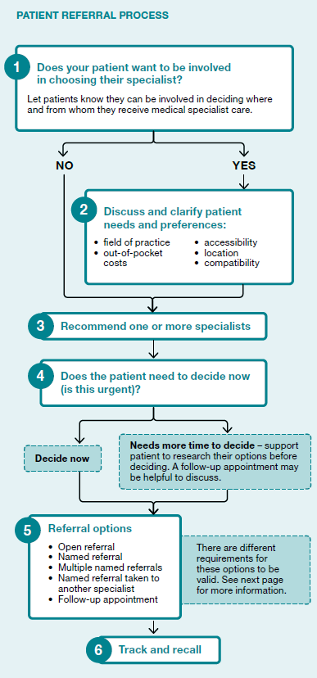

References
- Australian Medical Association. Informed Financial Consent. 2020 www.ama.com.au/articles/informed-financial-consent (accessed 14 December 2023)
- Dunlea R, Lenert L. Understanding Patients’ Preferences for Referrals to Specialists for an Asymptomatic Condition. Medical decision making : an international journal of the Society for Medical Decision Making 2015;35:691-702. https://pubmed.ncbi.nlm.nih.gov/25589523.
- Royal Australian College of General Practitioners. Information sheet: Informed patient decisions. East Melbourne: Royal Australian College of General Practitioners, 2019. https://www.racgp.org.au/FSDEDEV/media/documents/Running%20a%20practice/Practice%20standards/5th%20edition/RACGP-Information-sheet-Informed-patient-decisions.pdf
(accessed 14 December 2023).
- Productivity Commission. Introducing Competition and Informed User Choice into Human Services: Reforms to Human Services, Inquiry Report. Canberra: Productivity Commission, 2017. https://www.pc.gov.au/inquiries/completed/human-services/reforms/report (accessed 14 December 2023).
- Allen J, King R, Goergen SK, et al. Semistructured interviews regarding patients’ perceptions of Choosing Wisely and shared decision-making: an Australian study. BMJ Open 2019;9:e031831. https://bmjopen.bmj.com/content/bmjopen/9/8/e031831.full.pdf
- Royal Australian College of General Practitioners. Standards for general practices. East Melbourne: Royal Australian College of General Practitioners, 2020. https://www.racgp.org.au/running-a-practice/practice-standards/standards-5th-edition/standards-for-general-practices-5th-ed
(accessed 14 December 2023).
- Di Blasi Z, Harkness E, Ernst E, et al. Influence of context effects on health outcomes: a systematic review. Lancet 2001;357:757-62.
- Services Australia. Referring and requesting Medicare services. Canberra: Services Australia, 2020. https://www.servicesaustralia.gov.au/organisations/health-professionals/subjects/referring-and-requesting-medicare-services (accessed 14 December 2023).
- Australian Government Department of Health and Aged Care. Report: Ministerial advisory committee on out of pocket costs. 2018. www.health.gov.au/committees-and-groups/ministerial-advisory-committee-on-out-of-pocket-costs (accessed 14 December 2023).
- Commonwealth of Australia (2020). Addendum to National Health Reform Agreement, 2020-2025. https://federalfinancialrelations.gov.au/sites/federalfinancialrelations.gov.au/files/2021-07/NHRA_2020-25_Addendum_consolidated.pdf. (accessed 14 December 2023)

